Homework #4

Due in class on Tuesday, February 18, 2018. Datasets will be made available on Canvas as .csv files.

|  |  |  |  |
| --- | --- | --- | --- |
|  |  | # mice with… | |
| Site | Status | Fleas | NoFleas |
| 1 | Burn | 7 | 16 |
| 2 | Unburn | 1 | 3 |
| 3 | Burn | 9 | 22 |
| 4 | Unburn | 7 | 3 |
| 5 | Unburn | 8 | 1 |
| 6 | Unburn | 3 | 2 |

1. 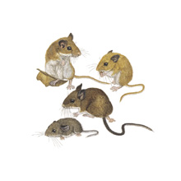The following data are from a study of deer mice (*Peromyscus maniculatus*) in six forest stands. Two forest stands had just experienced severe wildfires, and two had not. Mice were trapped for an equal amount of time in each stand, and each mouse that was captured was examined for external parasites. The following table summarizes data for one external parasite, fleas:
   1. Calculate the MLE parameter(s) for the proportion of mice that have fleas for three models: one in which the probability of fleas is the same for all sites, one in which burned and unburned sites differ, and one in which each site has its own probability
   2. Use AIC to decide which model is best
   3. Use LRT to decide which model is best

*If you are interested in the story behind these data, see Zwolak, R., et al. 2013 Ecosphere 4: article132*

|  |  |  |  |
| --- | --- | --- | --- |
| fertilizer | clone | # punctures | # galls |
| unfertilized | 1 | 34 | 9 |
| unfertilized | 2 | 33 | 6 |
| unfertilized | 3 | 33 | 1 |
| unfertilized | 4 | 27 | 4 |
| unfertilized | 5 | 36 | 0 |
| unfertilized | 6 | 32 | 12 |
| fertilized | 1 | 34 | 12 |
| fertilized | 2 | 34 | 13 |
| fertilized | 3 | 32 | 8 |
| fertilized | 4 | 30 | 2 |
| fertilized | 5 | 34 | 0 |
| fertilized | 6 | 61 | 9 |

1. A close up of a green leaf

   Description automatically generatedA close up of a green branch

   Description automatically generatedPlant galls are created when an insect living inside a plant manipulates the plant to grow tissues and structures that otherwise would not be found on the plant. Galls provide protection and nutrition to the gall former. To test whether nutrients affect the susceptibility of tall goldenrod to galling by the fly *Eurosta solidaginis*, researchers chose 6 “clones” (genetically identical plants) and grew plants of each clone either with or without fertilizer. Then, mated female gall flies were offered these host plants and researchers recorded the number of gall induction attempts (“punctures”) and the number of galls that developed on each plant as a result.

a. Use glm to estimate the MLE proportion of successful galling events (when a puncture results in a gall) for the entire dataset.

b. Use AIC to compare three models: the model you fit above in part a, a model that estimates different galling success rates for fertilized and unfertilized plants, and a model that estimates different galling rates by clone

c. For the third model, get the MLE galling success rates for each clone along with confidence intervals. Give an explanation for the 95% confidence interval for clone #5.

*Data from:* Brown, J.M., Abrahamson, W.G., Packer, R.A. et al. Oecologia (1995) 104: 52. https://doi.org/10.1007/BF00365562

|  |  |  |
| --- | --- | --- |
|  | status next year | |
| Year | dead | alive |
| 1988 | 4 | 96 |
| 1989 | 10 | 90 |
| 1990 | 7 | 93 |
| 1991 | 28 | 72 |
| 1992 | 2 | 98 |
| 1993 | 9 | 91 |
| 1994 | 7 | 93 |
| 1995 | 22 | 78 |
| 1996 | 13 | 87 |
| 1997 | 9 | 91 |
| 1998 | 10 | 90 |
| 1999 | 58 | 42 |
| 2000 | 7 | 93 |
| 2001 | 5 | 95 |
| 2002 | 8 | 92 |
| 2003 | 11 | 89 |
| 2004 | 2 | 98 |
| 2005 | 17 | 83 |
| 2006 | 13 | 87 |
| 2007 | 15 | 85 |

1. The table to the left shows survival data from a population of plants over a period of 20 years. (The species, *“*Bitterroot milkvetch” is found only in a small area along the Continental Divide between Montana and Idaho.) Figure out whether variation in survival among years is due to demographic stochasticity alone as follows:

a. Make a plot of survival probability over time

b. Fit a GLM that describes a linear change in survival probability over time. Use the coefficients from this model to write the equation for that line (HINT: use link = “identity” in your glm).

c. Add that fit line to your plot using the predict() function.

d. Use model comparison (AIC or LRT, your choice) to determine if there is a significant linear relationship between survival probability and time.

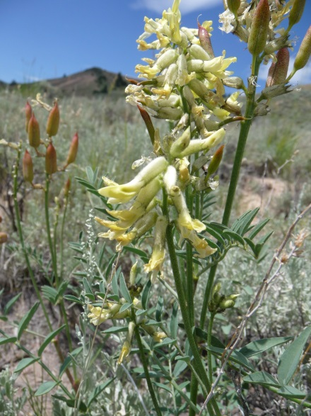

*For more background on endemic plants, see Lesica, P. et al. 2006 American Journal of Botany 93: 454-45*